SELECTAI INNOVATIONS PRIVATE LIMITED
Website Design
Page-1
Having a scroll related to the AI and highlight the AI work what we are representing.
Like: Future Ready AI

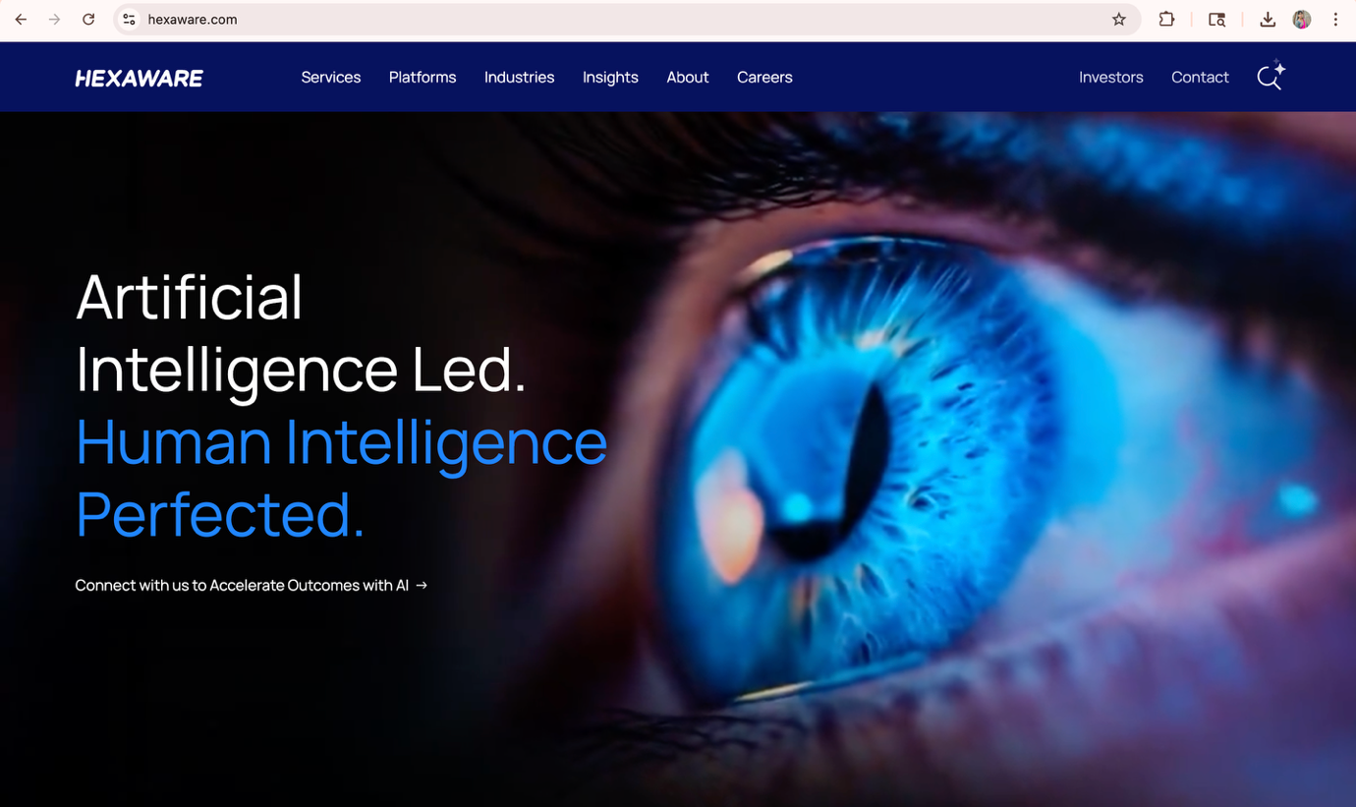

Partnered companies(Who we work with): https://hey.coach/
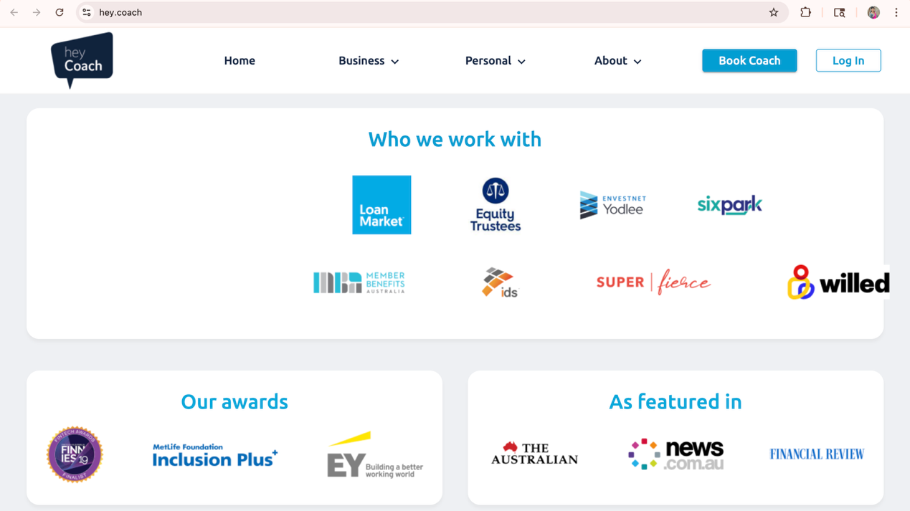

Team--Established by 2strong women
A small template to show strength

Feedback/Stack videos
It Solutions Stock Video Footage for Free Download https://share.google/ZmbBgL74tpLIXkTfE

Want to stay connected: https://dxc.com/
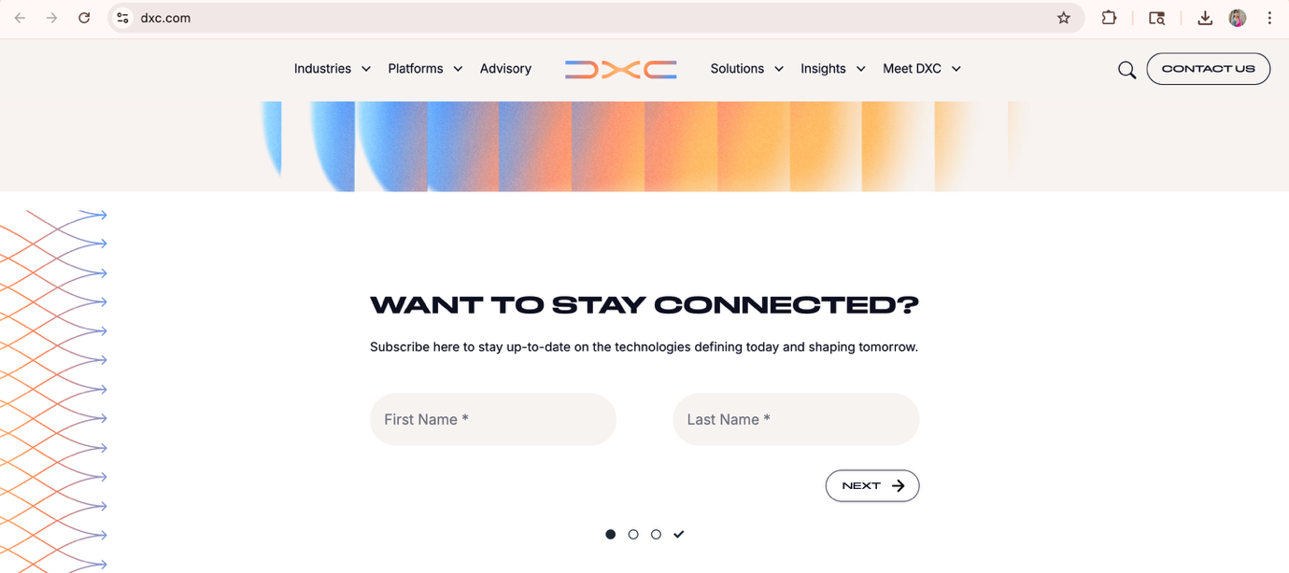
Find Out How SelectAI can Help You
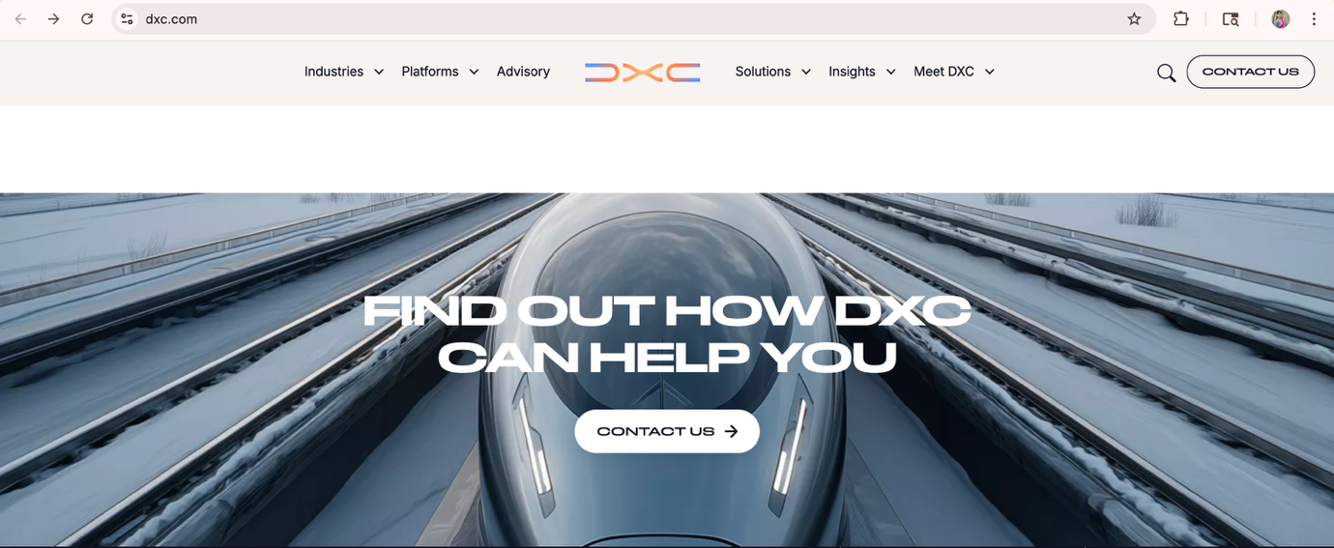
UP Button: https://www.coforge.com/
Why SelectAI, Our capabilities??
Reduce time quotes
Effective work
On Delivery time and flexibility
Maintaining good communication
- Services-- https://hexaware.com/
- Learning-- https://kodekloud.com/
- AI Products-- https://aws.amazon.com/
- AI Automation & Migration-- https://www.threeatoms.com/
- Contact Us
- About

